

A PROJECT REPORT

ON
HANDWRITTEN DIGIT RECOGNITION SYSTEM USING CNN AND STREAMLIT
Submitted in Partial Fulfillment of the Requirements for the
ARTIFICIAL INTELLIGENCE (AI) TRAINING PROGRAM
Theme: Sustainability

Submitted By

HUZAIFA NAZIR

Department of Artificial Intelligence

NATIONAL SKILL TRAINING INSTITUTE (NSTI)

SRINAGAR, JAMMU & KASHMIR

Academic Session
2025 – 2026

CERTIFICATE
This is to certify that Huzaifa Nazir has successfully completed the project titled "Handwritten Digit Recognition System Using CNN and Streamlit" during the academic year 2025–2026 as a part of the Artificial Intelligence (AI) Training Program.
The project work has been carried out under the guidance and supervision of the faculty/mentor and fulfills the requirements of the Artificial Intelligence (AI) Training Program.

ACKNOWLEDGEMENT
I would like to express my sincere gratitude to my project guide and faculty members for their valuable guidance, support, and encouragement throughout the development of this project.
I am thankful to my institution for providing the necessary facilities and resources required to complete this project successfully.
I would also like to thank my friends and classmates for their suggestions and support during the project work.
Finally, I express my heartfelt gratitude to my parents and family members for their continuous motivation and encouragement.
Huzaifa Nazir

TABLE OF CONTENT
S.No | Contents | Page No.
1 | Cover Page | 1
2 | Certificate | 2
3 | Acknowledgement | 3
4 | Table of Contents | 4
5 | Abstract | 5
6 | Aim of Project | 6
7 | Objectives | 7
8 | Project Theory | 8
9 | Methodology | 9
10 | Tools & Technologies | 10
11 | Flow Chart | 11
12 | Results/Screenshots | 12
13 | Conclusion | 13

Abstract
The Handwritten Digit Recognition System is a machine learning project that identifies handwritten digits from 0 to 9. The system uses a Convolutional Neural Network (CNN) model trained on the MNIST dataset. Users can upload an image of a handwritten digit through a Streamlit web application, and the system predicts the digit automatically. This project demonstrates the practical use of Artificial Intelligence and Deep Learning in image recognition.

Aim of the Project
To develop a web-based application that can recognize and predict handwritten digits (0–9) using a CNN model and Streamlit.

Objectives
• To collect and use the MNIST handwritten digit dataset.
• To train a CNN model for digit recognition.
• To build a user-friendly web interface using Streamlit.
• To allow users to upload digit images.
• To predict and display the recognized digit accurately.

Project Theory
Handwritten Digit Recognition is an application of Artificial Intelligence and Deep Learning. In this project, a CNN model is used to learn patterns from handwritten digit images. The MNIST dataset contains thousands of images of digits from 0 to 9. After training, the model can identify unknown handwritten digits and predict the correct number.

Methodology
• Collect the MNIST dataset.
• Preprocess the images.
• Train a CNN model using TensorFlow/Keras.
• Save the trained model.
• Develop a Streamlit web application.
• Upload handwritten digit images.
• Predict and display the digit.

Tools and Technologies Used
• Python
• TensorFlow
• Keras
• Streamlit
• NumPy
• Pandas
• Matplotlib
• Scikit-learn

Flow Chart
Start
↓
Load MNIST Dataset
↓
Train CNN Model
↓
Save Model
↓
Launch Streamlit App
↓
Upload Digit Image
↓
Preprocess Image
↓
Predict Digit
↓
Display Result
↓
End
Conclusion
Results/Screenshots
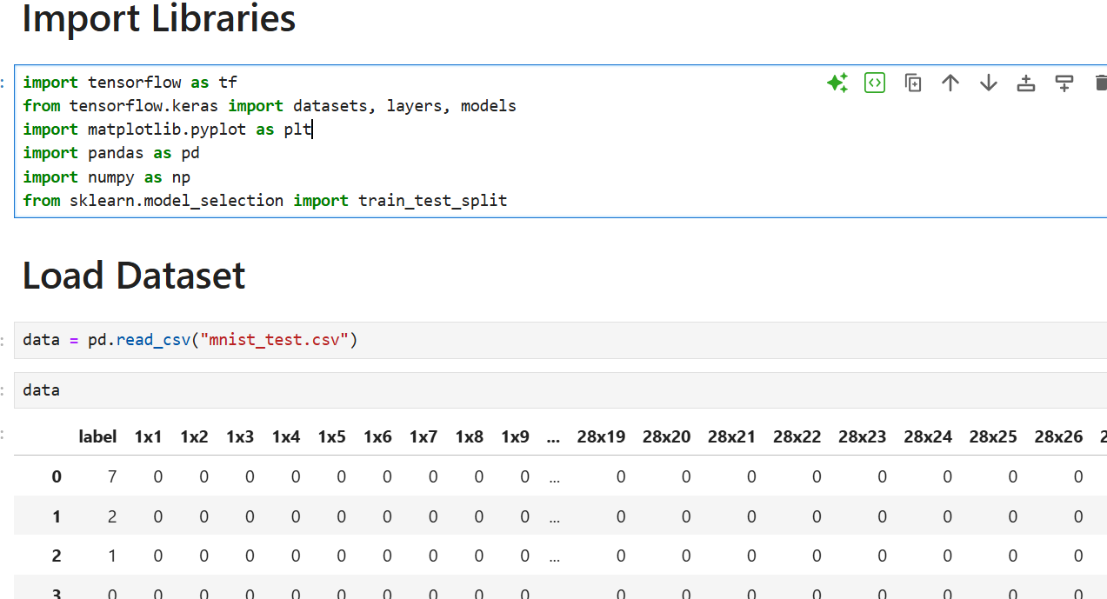
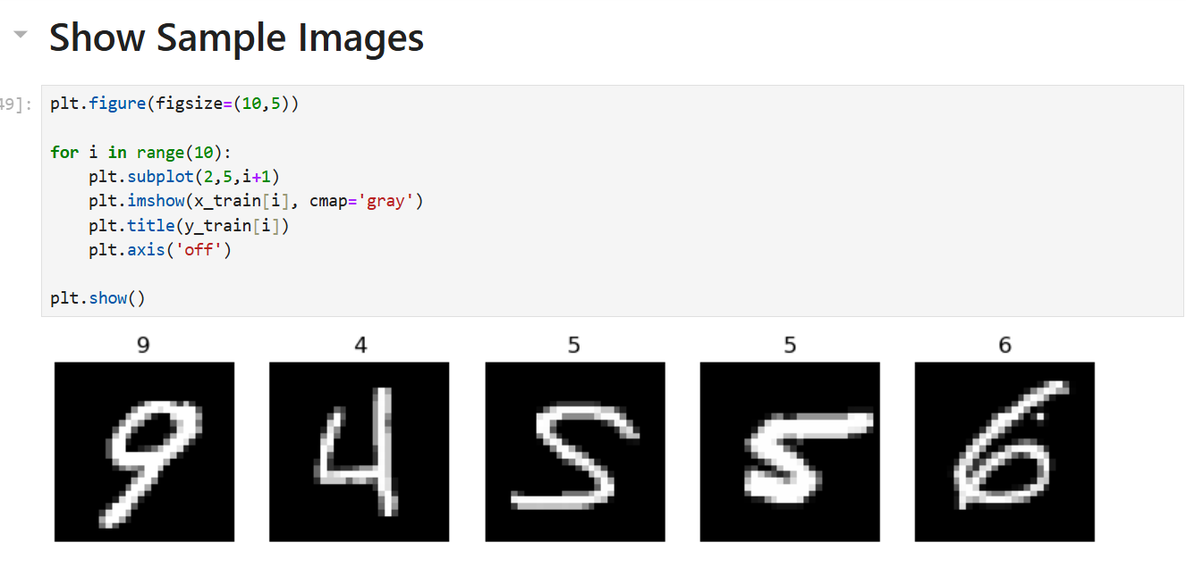
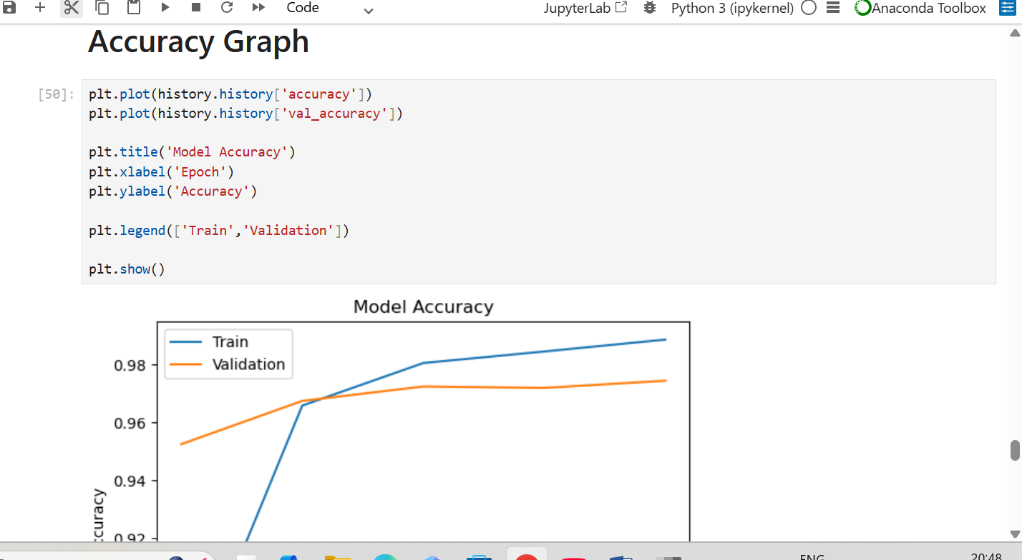

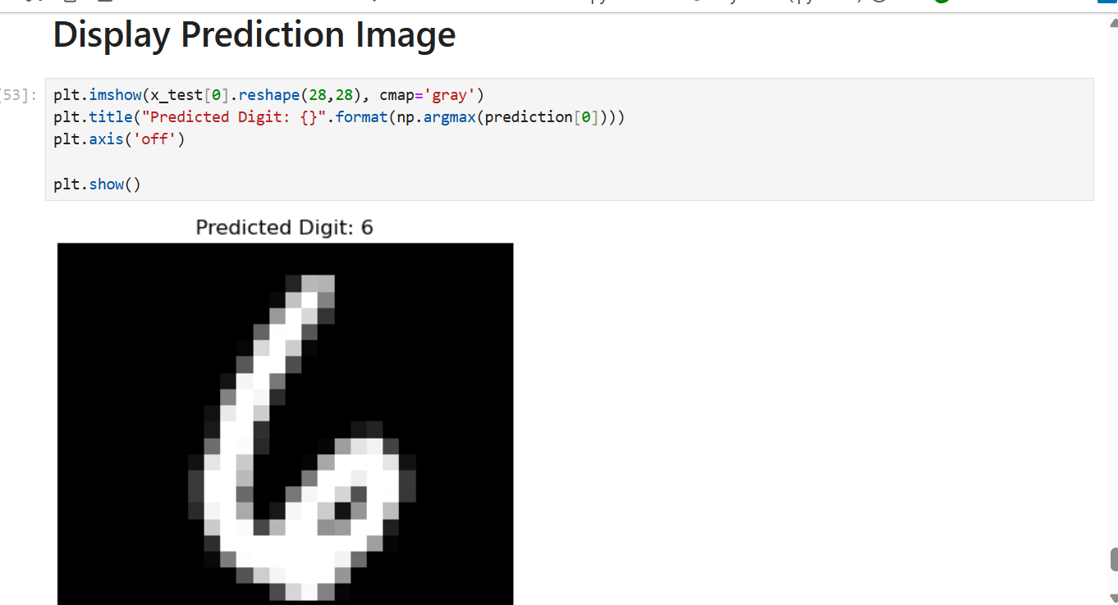

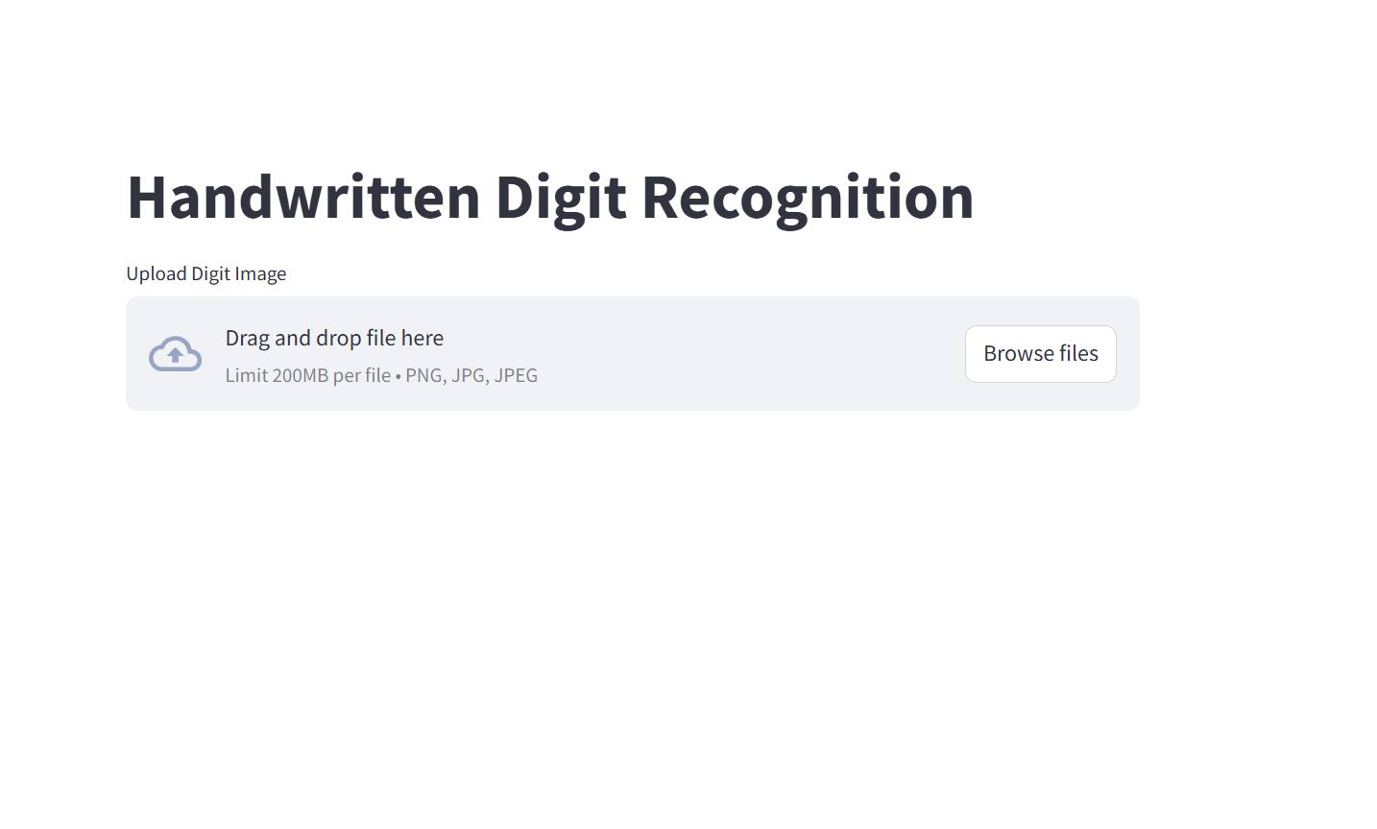

Conclusion
The Handwritten Digit Recognition System successfully recognizes handwritten digits using a CNN model. The project uses the MNIST dataset and provides predictions through a Streamlit web application. The system is accurate, efficient, and demonstrates the practical application of Deep Learning in image recognition.

